

**Project:-**

**Class Whiteboard Writing Robot**

**Subject:-**

Electronic Devices and Circuits

**Submitted to:-**

Engr. Tanveer Riaz

**Project Proposal**

**Submitted by:-**

2019-MC-255

2019-MC-263

2019-MC-273

2019-MC-281

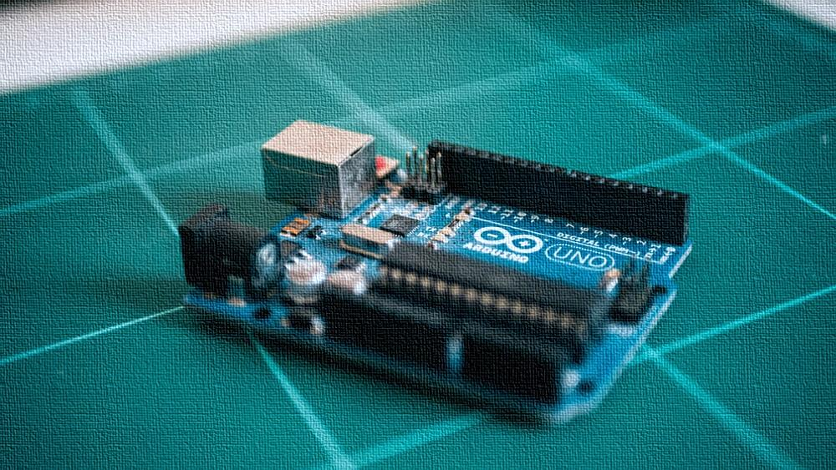

2019

**Project Name:-**

**Class Whiteboard Writing Robot**

**Background Concept:-**

We are using the concept of CNC (Computer Numeric Control) machines to make the robot. These are computerized controlled machines use electronics and computer software to do a specific task. Numerical control is a programmable automation in which process is controlled by Numbers, Letters, and symbols. CNC Machining is a process used in the manufacturing sector that involves the use of computers to control machine tools like lathes, mills and grinders. CNC use Numerical control is a programmable automation in which process is controlled by Numbers, Letters, and symbols. CNC Machining is a process used in the manufacturing sector that involves the use of computers to control machine tools like lathes, mills and grinders.

The main part of a CNC is its MCU (Machine Control Unit). The machine control unit (MCU) is the heart of a CNC system. It is used to perform the specific functions. It reads the coded instructions and decodes the coded instructions. It is used to implement movements (linear, circular, and helical) and to generate axis motion commands. It is used to feed the axis motion commands to the amplifier circuits for driving the axis mechanisms. It is also used to receive the feedback signals of position and speed for each drive axis. It implements auxiliary control functions such on/off controls of motors.

Another main part of the CNC and also our project is drivers. Drives are used to provide controlled motion to CNC elements. A drive system consists of amplifier circuits and drive motors. The MCU feeds the control signals (position and speed) of each axis to the amplifier circuits. The control signals are augmented to actuate drive motors which is used to position the machine tool. In CNC, usually stepper and servo electrical drives are used. They exhibit favorable torque-speed characteristics, accuracy and are relatively inexpensive.

**Introduction:-**

*“It will be an Arduino based machine which will use G-Code to draw vector graphics on a plane or board Surface. Actually, it will be a two axis vertical plotter based on ‘x’ and ‘y’ axis operated by using computer generated G-Code as a CNC machine is operated.”*

A V-Plotter is a drawing robot which uses two motors to move a hanging writing implement across a drawing surface. According to plan this device will also use stepper motors to move the pen on the plane surface and a servo motor will be employed to lift the pen from the surface while the movement of pen. The stepper motor driver is responsible for actuating the motors as required and electronically separating logic and power for safety and durability. The protoneer stepper motor is typically used for three-axis CNC machines. A fully programmed micro controller ‘Arduino’ will be used to process the machine code generated from G-Code by computer. The hardware which is the physical canvas, motor and electronics setup, the software which handles end user input, and the Arduino firmware which interprets commands from the software and controls the motors. A G-Code generated from a two dimensional graphical drawing will be sent to machine code generator and this machine code will be sent to arduino. This code then will drive the motors to draw that two dimensional object. Devices or apparatus used in this machine is shown below.

AS we can see the figure given below, two stepper motors will be fixed on the two corners of the surface of board and it will control the movement of the belt. We will convert rotational motion of the motors into translator motion of the pen by using belts. Timing pullies on the stepper motors will move the belts and belts will move the pen on the surface or board.

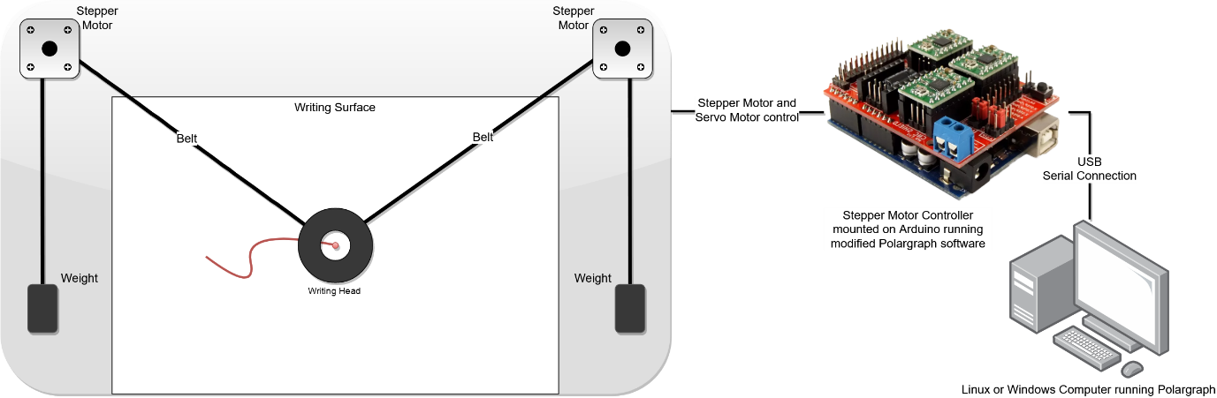

**Figure 1: Schematic Model of Machine**

**Apparatus:-**

* Arduino UNO
* CNC Shield for Arduino UNO
* Stepper Motor Driver A4988
* Stepper Motors
* Power supply (0-24V, 3A)
* GT2 Timing Pullies
* GT2 Timing Belt
* Servo Motor
* A Pen Holder (Gondola) with a pen or board marker
* Computer with some Software installed in it

**Working:-**

It will use the co-ordinate and axis system to position the pen on the board. Cartesian co-ordinate system is its base, and Cartesian co-ordinate system could be defined as the xy-plane is horizontal and the z-axis points up, and the x- and the y-axis form a positively oriented two-dimensional coordinate system in the xy-plane. Arduino UNO will guide the motors to move some steps according to the position given by G-Code. This position is obtained on the board by mathematical calculations and software saved instruction. These instructions are movement of pen in milli meters per step of rotation of stepper motor, machine dimensions and all other sizes and dimensions.

Its working is based on a combination of software to a great extent. It employs arduino as a main part. Arduino is a micro controller works according to its programming codes and frameworks. Initially arduino will be programmed to send and receive the instructions from the input device that is computer. After that it is connected to the CNC shield and Motor Drivers A4988. This combination of circuitry drives the stepper motors and a servo motor according to the instructions from G-Code. G-Code is also a Computer language that is used in CNC (Computer Numeric Controlled) machines. As this is also a CNC machine so it will use G-Code. G-Code can be given to computer by typing from keyboard but for complex graphical designs we can’t type G-Code because due to complexity. So, to tackle this problem there are software that convert a file directly to G-Code. In our case will also use this type of software.

Now, G-code is processed by computer and sent to the arduino. Arduino further processes this G-Code and send instructions to CNC shield to Drive Motor using A4988 Motor Driver. This type of concept we will use to draw a two dimensional drawing.

It will be simple to use, we only have to do following tasks only to draw or write something on a whiteboard after its installation on the board:-

* Fix the pen or board marker in the Gondola (pen holder).
* Plug USB cable into the arduino and start polargraph software.
* Connect power supply with the stepper motors.
* Upload your drawing to computer.
* Convert it to vector graphics, if required.
* Upload it to processing and set its size, position and zoom.
* Tap draw to draw this vector form.

After this small process it will start the drawing on the board.

**Basic Units:-**

Some main parts of our robot are discussed below:-

* **MCU:-**

We are using Aruduino UNO as a MCU (Machine Controller Unit). It will perform all the tasks a MCU have to perform. It will receive the coded instructions from computer or input device in the form of G-Code and then it decodes the instructions and send these decoded instructions to the amplifier circuit which is also explained below. These decoded instructions are actually in the form of digital or analog signals which will be amplified by the CNC shield and stepper motor drivers. These signals or pulses will control the position of the pen on the work sheet or board surface. It will generate several types of motions and will perform all the tasks a MCU can perform. Thus arduino UNO is heart of our machine and provides a back bone to our robot.

* **Amplifier:-**

Amplifier circuit consists on the CNC driving shield and A4988 stepper motor drivers. They will receive the signals from the MCU or Arduino UNO and amplify this signal to drive the motor and generate movements. As we have discussed that the decoded signal from arduino will be a pulse and it will be of small amplitude so to provide it a gain we are using CNC shield and stepper motor A4988. This combination will amplifies the signal and provide an enough gain so that our stepper motor could rotate. This amplifier circuit is necessary to produce a torque to rotate motor and pen on the surface without this our stepper motor can’t rotate.

* **Drivers:-**

As we know Drivers is also an important part of a CNC and we are making a CNC robot so Drivers must be include in it. These drivers provide a drive or movement to our pen or tool on the board surface. We are using stepper motors, servo motor, timing pullies and timing belt as a combination of drivers. This combination will drive our pen on the board to make drawings of 2-dimentional objects. Stepper motors will control the axis motion of the pen and move it across the surface of our board. Servo motor will lift the pen when there is no need to write anything while movement. If we had not use servo motor then our pen write or draw the lines while moving from one place to other which we don’t require sometimes. Here, timing pullies and belts will convert rotatory motion of stepper motors into translator or linear motion of pen.

**Software:-**

Some software are employed for this machine, those are briefly explained below:-

* **Arduino IDE:-**

Arduino IDE (Integrated Development Environment) is computer software used to program the arduino board. It is also an interpreter and compiler for the arduino Code. This software use a special arduino language to program the arduino board. This software compiles and uploads the code into arduino board. The software use C and C++ language rules with some changings to program the arduino board. We will use this software to program our arudino to drive Stepper and Servo motors. We will upload our polargraph firmware to the arduino required for our project.

* **Processing with Polargraph:-**

Processing and Polargraph both will be used to send G-Code to the arduino and to setup our machine on a board or plane of any dimensions. We can say that we can use this Robot for an infinite dimensioned board with the help of this software. Its basic purpose is to setup our Robot on a board of our desired dimensions. These software also send a G-Code to arduino, generated from a graphical or vector file. This combination will provide a framework to draw vector graphics on the plane surface. These software use mathematical calculations and Cartesian co-ordinate to guide the arduino to rotate the motors to move pen. This software is also used to set our drawing dimensions and our drawing positions on the board, with this software a drawing we can adjust that where should our drawing will be drwn on the baard and how magnified it will be from original drawing. Magnification means it could be larger or even smaller from original vector files’ dimensions of drawing.

* **Inkscape:-**

Inkscape is also computer software. It is a vector graphics editor. It is used to convert a picture or a graphical file to a vector file which will be given to CNC machine in form of G-Code or directly to G-Code. It can also be used to edit pictures and other graphic files. As it is vector graphic drawing machine so this software is necessary for out robot to draw vector graphics. We will employ this software to convert our picture files or text to vector form or G-Code files, and sometimes to .svg when requires to do so.

**Working Diagrams:-**

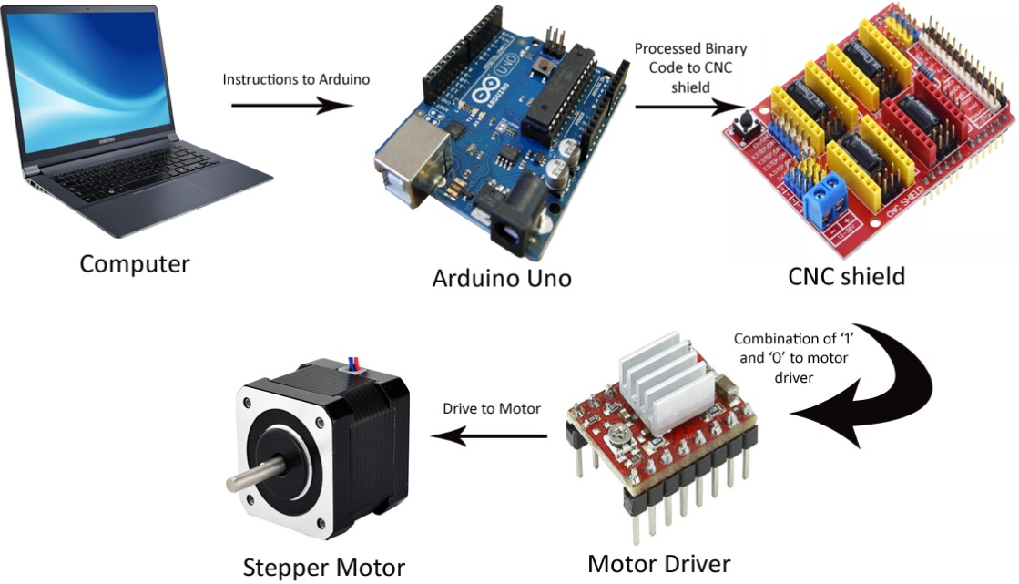

Figure 2: Schematic Diagram of Working of Machine

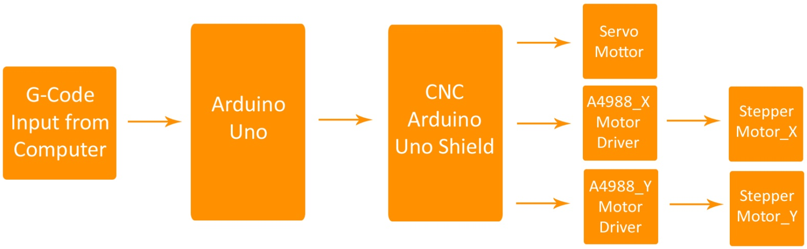Figure 3: Basic Block Diagram of Working of Machine

**Applications:-**

* As from the name its wide application is in educational institutes. It is a White board writing Robot so it will be employed to draw complex drawings on a white board and could be used to write very efficiently speedily.
* It can be used to write white board automatically in class rooms, lecture halls, Auditoriums etc.
* It could be used as a printer on a small scale could be used to print document or vector graphics neatly and precisely.
* It can be used to plot CAD models on paper as well as on board very easily.
* Some modifications required and then it could be used as a milling CNC’s base.
* This concept can also be used to make a laser engraver. A change we have to do is only to control laser intensity instead of servo motor for pen.

**Limitations:-**

It has some limitations and those are given below:-

* It cannot be used to print high resolution vector graphics because it is using arduino UNO and it is not such a good mirco controlling kit that it decodes such a coding that is encoded during processing of a high resolution vector graphics file.
* It cannot be used to print multicolor graphics file because there not an option in this machine like tool change or pen change and multicolor graphic files have high resolution so it could break the programs and can damage arduino UNO.
* Do not use it to make a very lengthy drawing so that it can take 2-3 hours to complete. Because, it can disturb our amplifier circuit and can cause to heat up the CNC shield and motor driver A4988 even if heat sink are present.